muaythaigp.com

MUAY THAI GRAND PRIX

BACKGROUND.
Muay Thai Grand Prix (MTGP) was founded in 2012

Over the last ten years we’ve delivered over 150 LIVE Events in 15 Countries with multiple broadcast and streaming partners including UFC Fight Pass, Box Nation and Samsung TV.

MTGP is currently the Number One Muay Thai promotion in the World.

MTGP in association with Live Nation will present MTGP Paris at Zenith Arena 24th June 2023 featuring Japanese Superstar TAKERU
streamed live PPV on Abema TV Japan and FITE TV Worldwide.

MTGP has 24 events scheduled for 2023
WWW.MUAYTHAIGP.COM
RAW AUTHENTIC DIGITAL-FIRST FAN-FRIENDLY UNPREDICTABLE

Muay Thai (Thai Boxing) is a Martial Art and a Combat Sport that uses the ‘Art of Eight Limbs’, as it’s characterised by the use of fists, elbows, knees and shins. In 2021 Muay Thai was officially recognised as an Olympic Sport.
Amateur Muay Thai was in the World Games 2022 and the European Games in 2023.

2024
2023
2021
2012
1996
1994
1992

HISTORY OF

MUAY THAI.

MTGP Streaming Service launches bringing monthly Muay Thai Shows to EMEA audiences.
Amazon Prime stream live Muay Thai from the Lumpini Stadium.
The IOC Officially recognise Muay Thai as an Olympic Sport. 2023 Muay Thai is featured in the European Games.
Muay Thai Grand Prix launches, bringing Muay Thai Promotions to the UK.
French Televison Network Canal+ broadcast Lumpinee Stadium Championship Fights.

ESPN broadcast bouts from the Lumpinee Stadium.

1992 Sky Sports broadcast Muay Thai fights from the Rajadamnern Stadium.

WWW.MUAYTHAIGP.COM
1955
Rajadamnern Stadium in Bangkok hosted the first televised Muay Thai bout on Thai TV Channel 4.

FOUNDER & CHAIRMAN
PHILLIP TIEU.
CEO

PAUL HENNESSY.

MTGP founder and chairman Philip has studied multiple martial arts disciplines over 30 years, finding his natural home with Muay Thai where skills could be tested in combat. Philip founded Team Tieu a competitive Muay Thai team that produced 15 professionally ranked fighters who won multiple titles.

Team Tieu using its wealth of experience developed Combat Sports classes for the general public and fitness enthusiasts incorporating techniques and training drills used by professional Combat Sports Athletes. Team Tieu partnered with Gymbox and currently deliver over 100 weekly classes across 10 Gymbox London sites.

Philip founded MTGP in 2011 initially as a platform to showcase Team Tieu fighters but it quickly became the UK’s No. 1 Muay Thai promotion. Philip focused on MGTP adding divisions KGP (Kickboxing) and MMAGP (Mixed Martial Arts) producing sold out events and attracting the attention of UFC Fight Pass and securing a streaming deal. Philip laid the foundations for MTGP to grow into a global Combat Sports brand.
Paul has been involved in sports management for more than 30 years, working primarily in Combat Sports including Boxing, Karate, Kickboxing, Muaythai, Mixed Martial Arts and Professional Wrestling.

He has been a successful promoter staging several series of televised events both in the UK and abroad as a manager he has represented leading Combat Sports athletes including Three times K-1 Champion Peter Aerts, UFC fighters Stefan Sturve, Terry Etim, Paul Taylor and James Te Huna amongst others.

As a consultant Paul has worked for Sports Leagues, promoters, TV Production companies and major Combat Sports brands including Bellator MMA, K-1 WGP and GLORY Kickboxing.

Paul sits on the board of the ISKA (International Sport Kickboxing Association) the world’s largest sanctioning body for combat Sports. The ISKA annually regulates over 500 events in more than 70 countries, Paul currently serves as President of ISKA Europe.

PARTNERSHIPS.

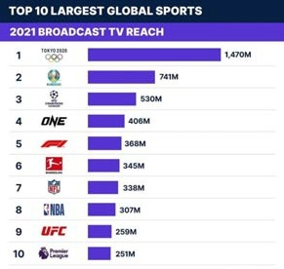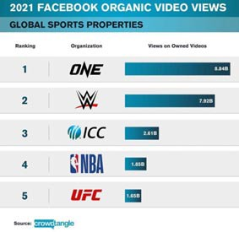

THERE'S NEVER BEEN SO MANY

EYES ON COMBAT SPORTS.

WWW.MUAYTHAIGP.COM

LOCATIONS.

Iraq HHHH Baghdad Italy iii Rome Spain Barcelona France fff Paris Cyprus ``` Limmasol Mexico Yucatan Greece Athens Bulgaria 999 Sofia
Vietnam vv Ho Chi Minh Denmark dd Copenhagan Portugal Lisbon Australia ^^^
Perth

Ivory Coast 000
Abidjan
Reunion Island Saint Denis Switzerland qq Geneva
United States uuuu
Miami • Los Angeles

ESTABLISHED
2012

LIVE EVENTS

50+

COUNTRIES

15+

YEARS

10+

YOUTUBE

20M+

FOLLOWERS

1M+

AUDIENCE
Established Audience*

18-34
Male Demographic

20-35
Female Demographic

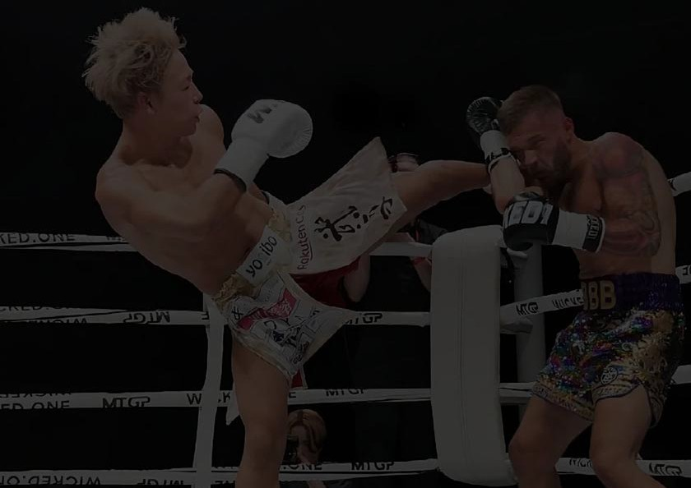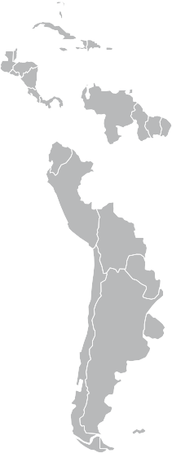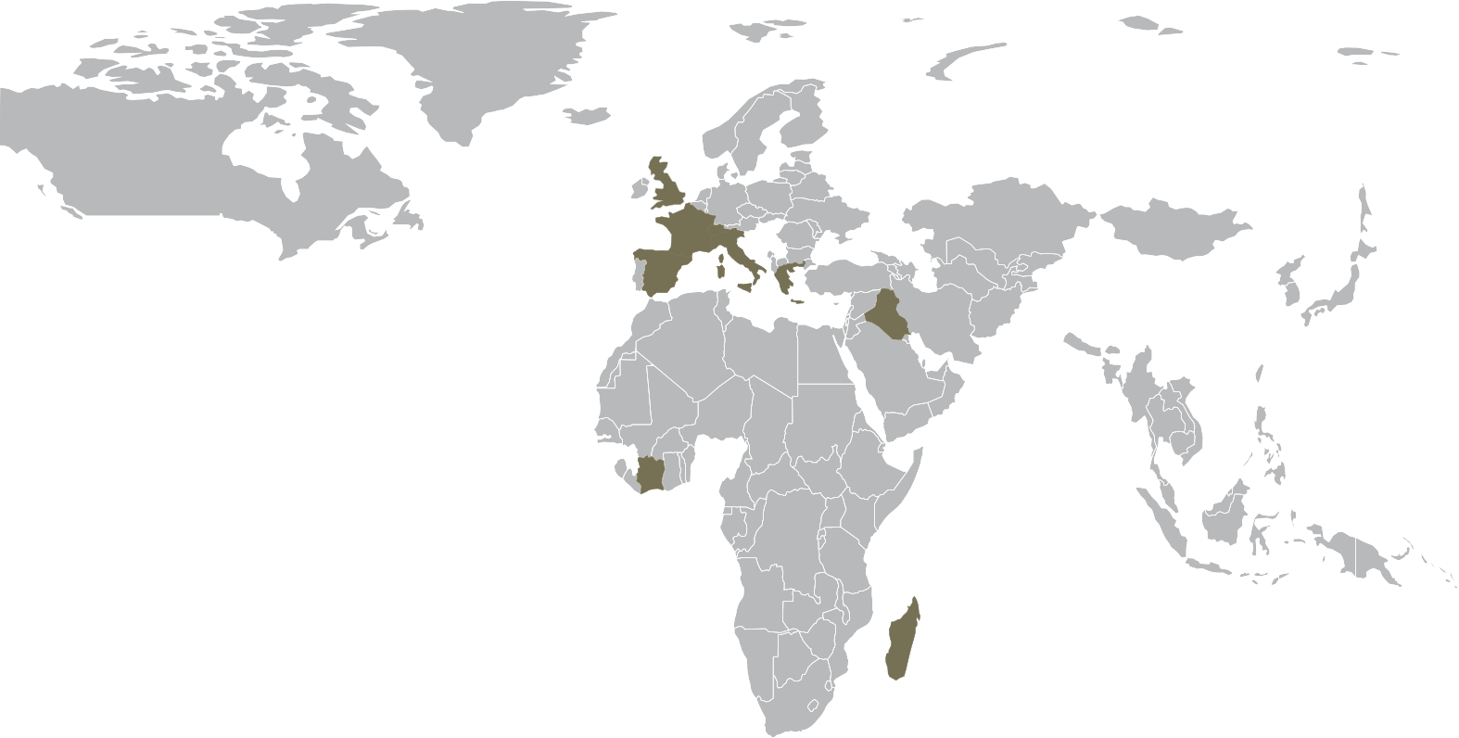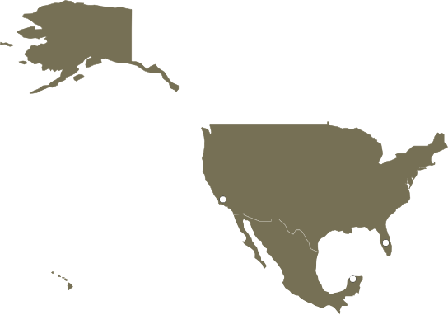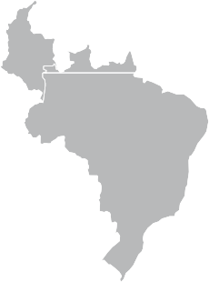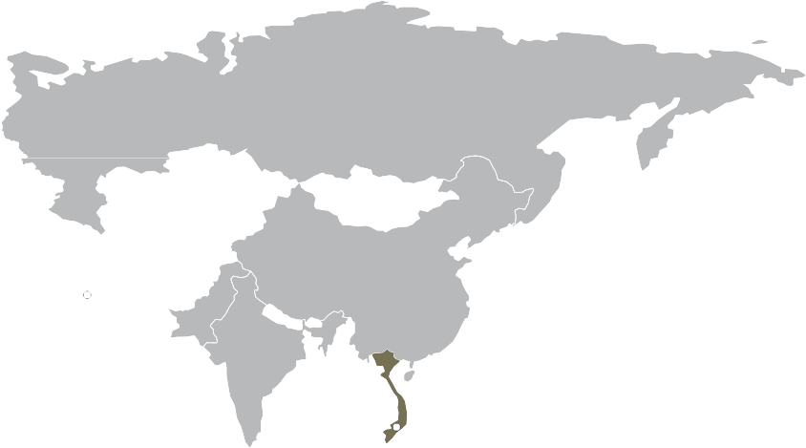United Kingdom !!!
London • Liverpool • Manchester
WWW.MUAYTHAIGP.COM

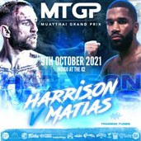MTGP GROUP.
MTG?W G?

M THAI GRAND PRIX

YTHAI GRAND PRIX
ED MARTIAL ARTS GRAND PRIX

KBOXING GRAND PRIX

WWW.MUAYTHAIGP.COM
KK
KUNKHMER GRAND PRIX
a-'

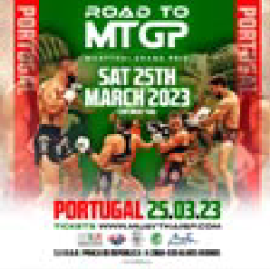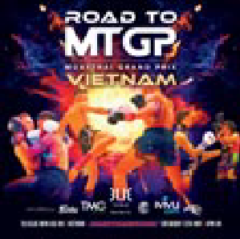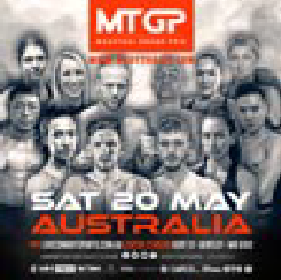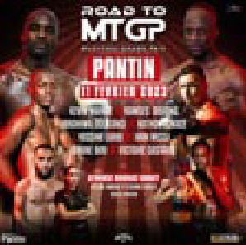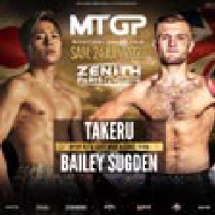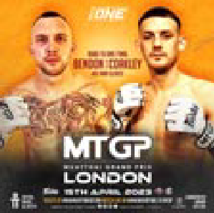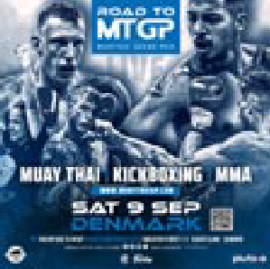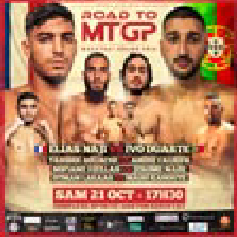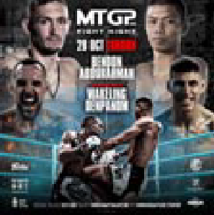SCHEDULE. 2023

FRANCE PARIS 16TH NOV
2023

SPAIN ALICANTE 25TH NOV
2023

